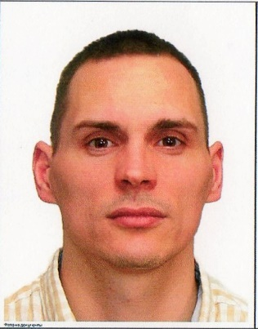

Vladislav Tkachenko
Belhorod – Dnestrovskiy,
Mayakovskiy str., 40
Cell n.:+380675380568
e-mail: vtkachenko61@gmail.com
DOB: 13/05/1986

Personal summary
I am a loyal responsible person, who has been working for the last 3.5 years as an area manager and farm manager with the finisher production as my responsibility and later as a farm manager of the whole production where I together with the head of the pig production built up a finisher production with 63000 pen places. Through this position I have developed myself so today with minimum support I handle all procedures as the delivering planning, employees’ training, new strategies’ implementation, organize daily works, so today I consider myself as a self-running person in the production.
WORK EXPERIENCE
Halychyna-Zahid
November 2018 – March 2019
Production manager(Klima and Fattening)
- 7000 sows, 30000 piglets (7-30 kg), 45000 finishers (30-110 kg)
- Working processes management
- Feed system (Weda & Big Dutchman) management
- Responsible for daily operations
- Making reports
- Implement of the strategies
- Daily operations’ planning
- Employees training

DFU Agro
February 2017 – November 2018
Production manager(Fattening)
4300 sows,13000 piglets (7-30 kg),16000 finishers (30-120 kg)

PJSC “Agrokombinat “Slobozhanskiy”
May 2013- February 2017
Area manager (Fattening) and production manager
- 4500 sows, 19000 piglets (7-30 kg), 63000 finishers (30-125 kg)

Halychyna-Zahid
September 2008 – April 2012
- 3500 sows, 16000 piglets (7-30 kg), 28000 finishers (30-110 kg)

2008-2011 studying at Belhorod-Dnestrovskiy State Agrarian College on speciality technician-hydrotechnician

Advanced PC user: Microsoft Office, liquid feed computer “Big Dutchman”, “Weda “ ,ventilation computer “Skiold”, “Skov”, “Hog Slat”
Languages: Russian, Ukrainian – fluently, English – Pre-Intermidiate
International passport is available
Willingness to travel

Personal information

Married, one child

